Chapter 13, Problem 28.

In the circuit in Fig. 13.96, find the value of X that will give maximum power transfer to the 20-Ω load.

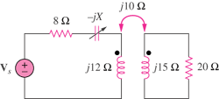

Figure 13.96
For Prob. 13.28.

